**Practical 4**

**Program:**

> df1 = data.frame(

+ y1=c(1,2,3),

+ y2=c(4,5,6))

> df2 = data.frame(

+ y1=c(7,8,9),

+ y2=c(1,4,6))

> listofDataframe=liat(df1,df2)

Error in liat(df1, df2) : could not find function "liat"

> listofDataframe=list(df1,df2)

> print(listofDataframe)

**Output:**

[[1]]

y1 y2

1 1 4

2 2 5

3 3 6

[[2]]

y1 y2

1 7 1

2 8 4

3 9 6

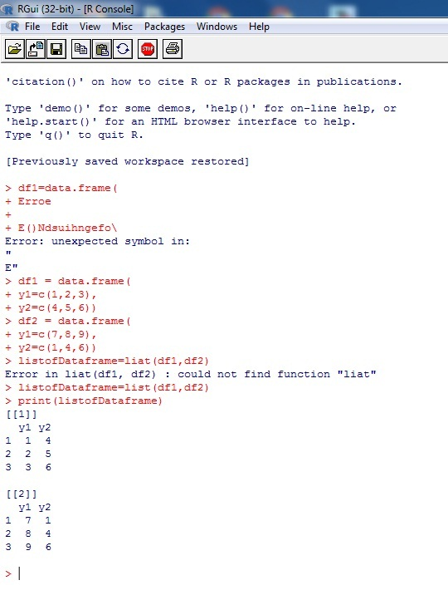

> #Accessing Components

> #Creating a list of dataframes by naming all it's Components

> listofDataframe = list(

+ "Dataframe1"=df1,

+ "Dataframe2"=df2)

> print(listofDataframe)

$Dataframe1

> #Accessing Components by name

> cat("Accessing Dataframe2 using $ command\n")

Accessing Dataframe2 using $ command

> print(listofDataframe$Dataframe2)

**Output:**

$Dataframe1

y1 y2

1 1 4

2 2 5

3 3 6

$Dataframe2

y1 y2

1 7 1

2 8 4

3 9 6

y1 y2

1 7 1

2 8 4

3 9 6

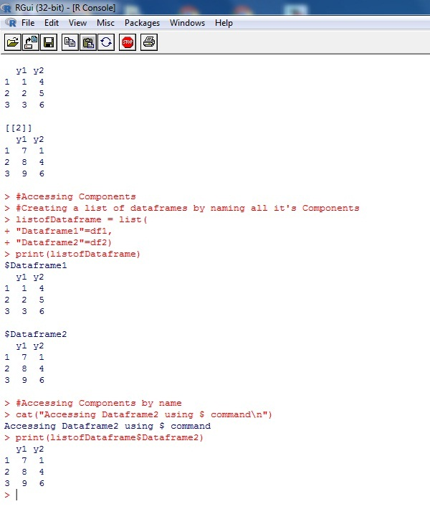

> #Accessing a top level components by indices

> cat("Accessing Dataframe2 using indices\n")

Accessing Dataframe2 using indices

> print(listofDataframe[[2]]

+ print(listofDataframe[[2]])

Error: unexpected symbol in:

"print(listofDataframe[[2]]

print"

> print(listofDataframe[[2]])

**Output:**

y1 y2

1 7 1

2 8 4

3 9 6

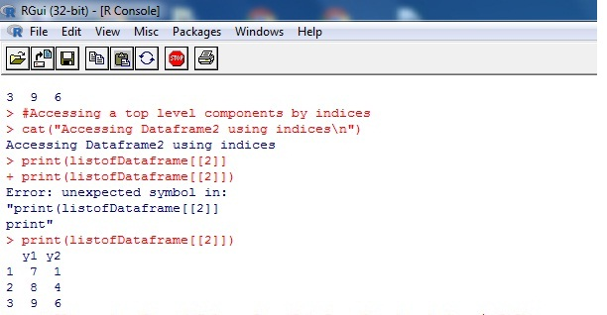

> cat("Accessing Second Column from Dataframe1 using indices\n")

Accessing Second Column from Dataframe1 using indices

> print(listOfDataframe[[1]][2])

Error in print(listOfDataframe[[1]][2]) :

object 'listOfDataframe' not found

> print(listOfDataframe[[1]][2])

Error in print(listOfDataframe[[1]][2]) :

object 'listOfDataframe' not found

> print(listofDataframe[[1]][2])

**Output:**

y2

1 4

2 5

3 6

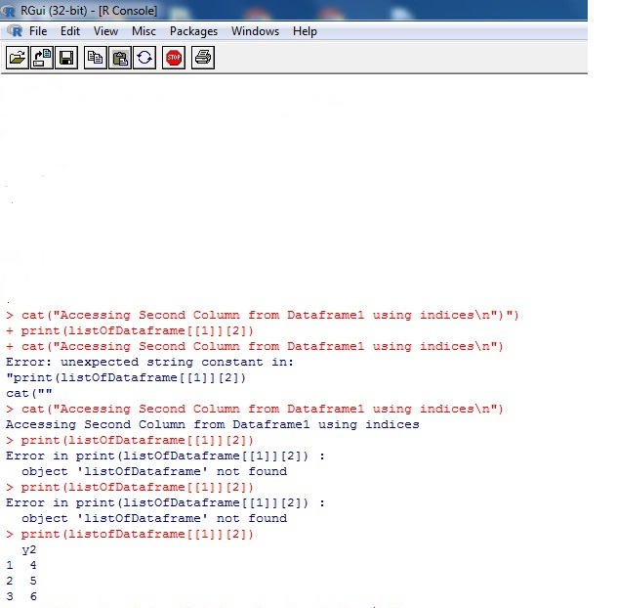

> cat("Accesing 4 from Dataframe2 using indices\n")

Accesing 4 from Dataframe2 using indices

> print(listofDataframe[[2]][2,2])

**Output:**

[1] 4

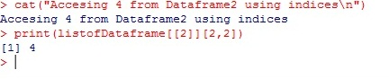

> #modifying Components

> cat("Before modifying the list of frame\n")

Before modifying the list of frame

> print(listofDataframe)

[[1]]

y1 y2

1 1 4

2 2 5

3 3 6

[[2]]

y1 y2

1 7 1

2 8 4

3 9 6

> #modifying dataframe2

> listofDataframe$Dataframe2 = data.frame y1=c(85,95,6),y2=c(25,26,27))

Error: unexpected symbol in "listofDataframe$Dataframe2 = data.frame y1"

> listofDataframe$Dataframe2 = data.frame (y1=c(85,95,6),y2=c(25,26,27))

> #Modifying Second Column from Database1

> listofDataframe[[1]][2]=c(23,66,73)

> #Modifying element2 from Dataframe1

> listofDataframe[[1]][2,1]=15

> cat("After modificat"\n")

Error: unexpected '\\' in "cat("After modificat"\"

> cat("After modificat\n")

After modificat

> print(listofDataframe)

[[1]]

y1 y2

1 1 23

2 15 66

3 3 73

[[2]]

y1 y2

1 7 1

2 8 4

3 9 6

$Dataframe2

y1 y2

1 85 25

2 95 26

3 6 27

> #Concatenation

> #Create Dataframe

> df1=data.frame(y1=c(1,2,3),y2=c(4,5,6))

> df2=data.frame(y1=c(7,8,9),y2=c(1,4,6))

> #naming Components

> listofDataframe=list("Dataframe1"=df1,"Dataframe2"=df2)

> cat("Before Concatenation")

Before Concatenation> print(listofDataframe)

$Dataframe1

y1 y2

1 1 4

2 2 5

3 3 6

$Dataframe2

y1 y2

1 7 1

2 8 4

3 9 6

**Output:**

